Unit Test Summary

Function name: unitAddedCorrectly

Method: Adds a user entity in the database and queries that it’s been added by asserting that the repository count is greater than one.

Test Results: Passed

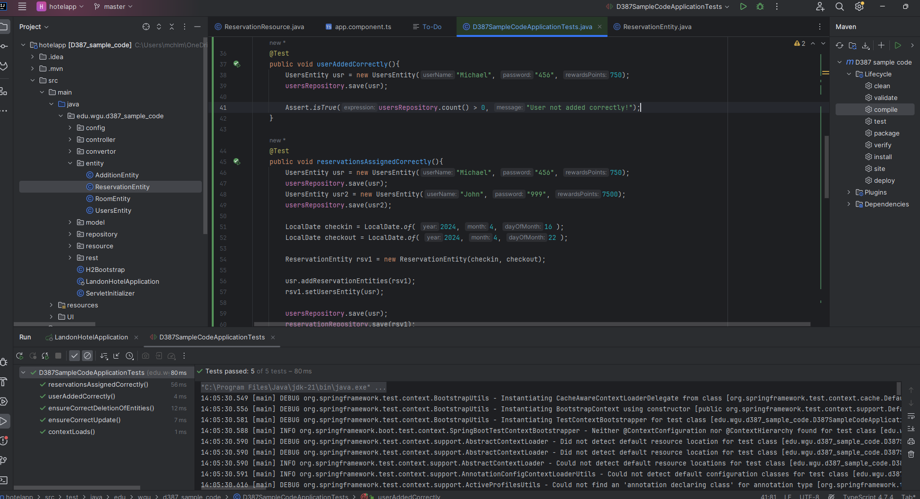

Function name: reservationAssignedCorrectly

Method: Creates two users and two reservations, assigns the reservation to one users, and queries to see if the user is holding the correct reservation and that the reservation has the correct data.

Test Results: Passed

Function name: ensureCorrectDeletionOfEntities

Method: Assigns and saves a new reservation to the database, then queries to see if the repository is not empty.

Test Results: Passed

Function name: ensureCorrectUpdate

Method: Creates a room entity, assigns it initial values, then change these values. Queries to see if the values have changed to the new value.

Test Results: Passed

**Summary of Changes**

Based on these tests, I conclude that I do not need to make any adjustments to the application. In a real-life software scenario, I would begin internally testing this version hands-on with other engineers.